SUDOKU PROBLEM

NAME: J.L.PUGAZH MUKILAN

REG NO: 22BCE9292 SLOT :L7+L8

SUDOKU CODE:

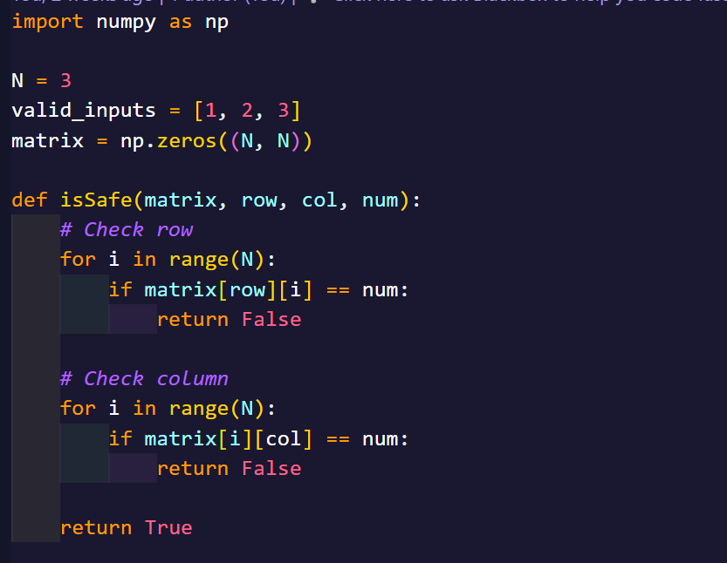 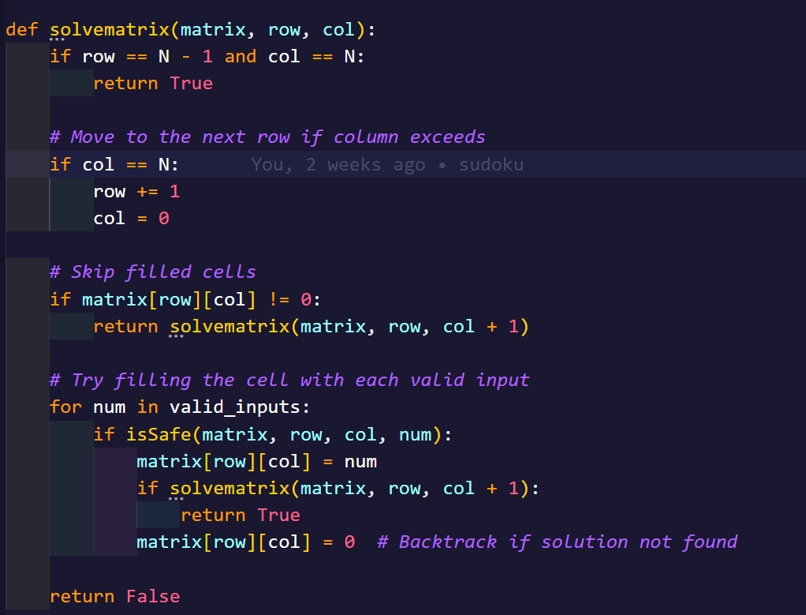

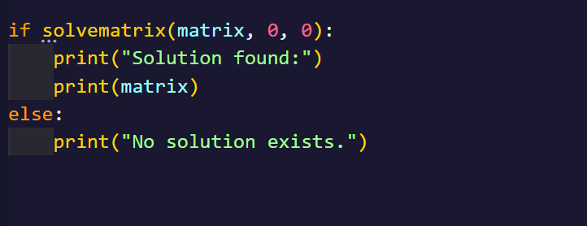

OUTPUT:

